Literacy support worksheet

6.1 The universe was studied by early Australians
Pages 140–141

Indigenous astronomy
1 What is a constellation?
2 Read the information below and answer parts a and b.
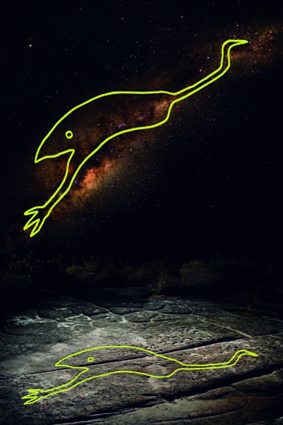
To the people living in the western desert, the emu constellation was part of their calendar. Its position helped them to know when to hunt or collect eggs.
a When the emu was running, what was it time for?
b When the emu was sitting, what was it time for?
3 The emu constellation is actually a part of which galaxy?

Word detective – Draw and explain
4 Draw and explain an experience or outdoor activity that has a special meaning for you, on the pictogram of the Southern Cross below. It may be something that you like to do at particular times of the year, perhaps with family or friends. (Some examples could include camping, water skiing, surfing, fruit picking, bushwalking, certain sports or holidays).


Literacy support worksheet

6.2 The Earth is in the Milky Way
Pages 142–143

Stellar magnitudes, parallax and distances
1 What are stars?
2 Name three features that can make stars different from each other.
3 What two elements are stars made of?
4 Use the following word list to fill in the blanks in the paragraph below.
Word list: close, positive, dimmer
The apparent magnitude scale is a measure of how bright a star ‘appears’ to be. The more ____________________ (and the less negative) the number, the ____________________ the star. A star may appear to be quite bright because it is ____________________ to the Earth; it may not actually be very bright.
5 The colour of a star is an indicator of its surface temperature. Complete the following sentences.
a ‘The hotter the surface temperature of the star, the ___________________ the colour.’
b ‘The colder the surface temperature of the star, the ___________________ the colour.’
6 What is one method of measuring stars using colour?
7 How long does it take for the light from the Sun to reach:
a the Earth?
b Proxima Centauri?
8 Our Sun has a surface temperature of about 5700 K and an absolute magnitude of 4.77. Use this information to show where our Sun would be positioned on the Hertzsprun–Russell diagram below.

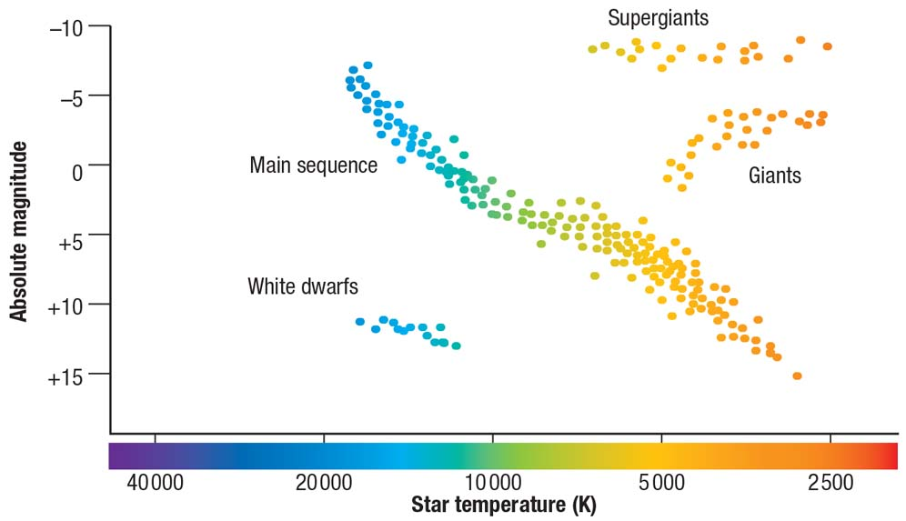

Word detective – True or false
9 Read the statement and circle whether it is true or false.
a Gases reacting at the core of a star provide energy to the star. T or F
b Nuclear fusion occurs when two atomic nuclei are repelled. T or F
c The Sun is the brightest object in the sky. T or F
d Luminosity refers to how bright a star appears to be. T or F
e Light-years measure the distance of stars from the Sun. T or F
f Proxima Centauri is the next closest star to the Earth, after the Sun. T or F
g Every night our stars and planets move across the night sky. T or F
Literacy support worksheet

6.3 Stars have a life cycle
Pages 144–145

Stellar evolution
1 This image shows what happens with an initial mass greater than eight solar masses, and a core mass greater than three solar masses.
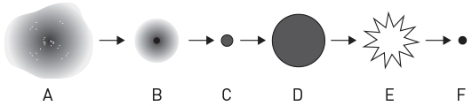
Use the following word list to correctly identify each of the stages (A to F) in a star's life cycle below. (Hint: Use Figure 6.10 in the student book as a guide.)
Word list: supernova, protostar, gas and dust, red giant star, neutron star, main sequence
Stage | Word | Stage | Word
A |  | D
B |  | E
C |  | F
2 In about 5 billion years from now, our Sun will form a red giant star through the fusion of helium atoms. Because of its size, the Sun will swallow up which four planets?
3 Our Sun is a main sequence star in hydrostatic equilibrium. There are two opposing forces that have become balanced so that the Sun is a consistent size. What are these forces?

Word detective – Story board
4 Create a story board or cartoon strip showing the changes that occur during the life cycle of a star.
Literacy support worksheet

6.4 The galaxies are moving apart
Pages 146–147

Spectra, the Doppler effect and galactic motion
1 Look at Figure 6.14 in the student book and observe a continuous spectrum, an emission spectrum and an absorption spectrum. Use this information, and the diagram below, to help you answer the questions below.
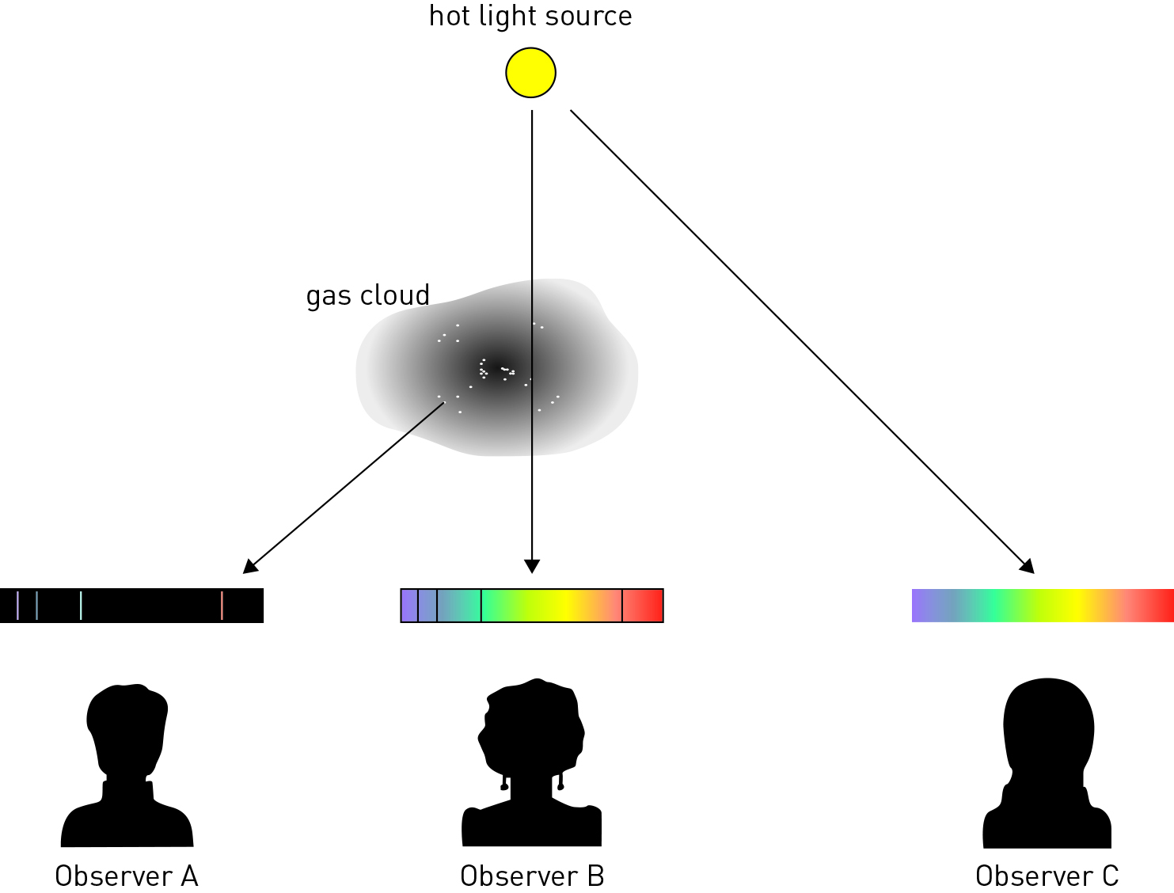
In the diagram above, which observer would see:
a a continuous spectrum?
b an emission spectrum?
c an absorption spectrum?

2 What is the Doppler effect?
3 What did Hubble discover about a distant star besides the spectra of light emitted by galaxies?
4 Observe Figure 6.15 in the student book.
Star A shows a star that isn’t moving towards or away from us.
Star B shows that compared to Star A above, the lines have moved slightly right, towards the red wavelength, which means that the galaxy is moving away from the Earth.
Star C shows that the lines have moved slightly to the left, towards blue, compared to Star A which means that the galaxy is moving towards the Earth.
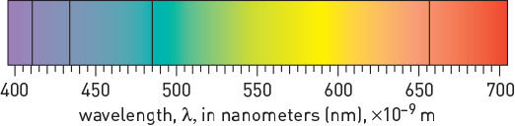  Figure 1 | 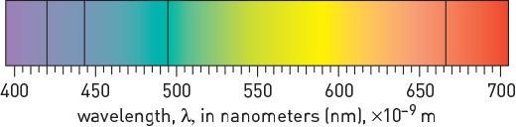  Figure 2
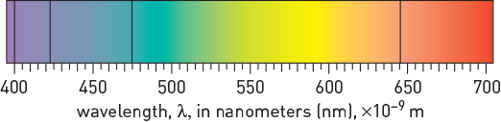  Figure 3 | 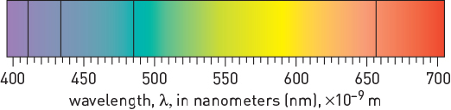  Figure 4
Observe Figures 1, 2, 3 and 4 above and answer the questions below.
Figure 1 shows a spectrum for hydrogen obtained in the laboratory.
Which one of Figures 2 to 4 best represents the hydrogen spectrum for a galaxy that is heading towards Earth? Explain your answer.

Word detective – Draw and label
5 Draw a diagram demonstrating the Doppler effect and label the sound wave frequencies.
(Hint: Use Figure 6.13 in the student book as a guide.)

Literacy support worksheet

6.5 The Big Bang theory is supported by evidence
Pages 148–149

Our expanding universe
1 What is the Big Bang Theory?
2 Complete the table below to show three pieces of evidence that support the Big Bang Theory.
Evidence 1:
Evidence 2:
Evidence 3:
3 In 1965, two US scientists found that leftover energy existed as background radiation. What was the energy left over from?
4 What award were these scientists given for their discovery?
5 When we look at far away galaxies, we can look back in time. How is this possible?

Word detective – Complete the sentence
6 Use the following word list to fill in the blanks in the sentences below.
Word list: singularity, Hubble, cooled, evidence, expanding
a The fact that galaxies are moving further away from us shows that the universe is ______________________.
b The universe has ______________________ since the Big Bang.
c Scientists believe the universe began from a single hot point called a ________________.
d _________________ discovered that space is expanding and taking galaxies with it.
e The Big Bang theory is supported by many forms of __________________.
Literacy support worksheet

6.6 Technology aids cosmological research
Pages 150–151

Cosmological research
1 What is the name of the $160-million-dollar project being built in Western Australia?
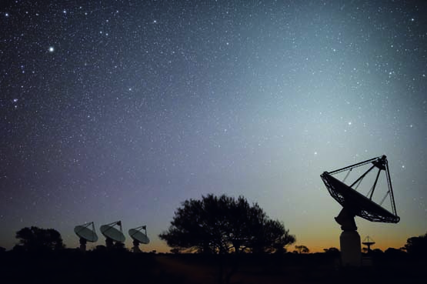
2 Complete the following sentence:
‘The project has seen the installation of 36 huge antenna dishes on Boolardy Station, which will
eventually work together to survey large areas of sky to help scientists understand
_______________________.’
3 Use the following word list to fill in the blanks in the paragraph below.
Word list: millions, holes, universe, telescopes, galaxies, survey
The latest picture we’ve taken has almost 2000 _______________________ in it, which is incredible,’ she said. ‘It’s kind of a wide field image in the sky. Once we’ve got 36 _______________________ we’ll be able to do a huge _______________________ of the entire night’s sky and see _______________________ of new galaxies, black _______________________ and things in the very distant _______________________ that no one’s ever seen before.’ – Lisa Harvey-Smith
4 Name two things that scientists have been able to observe so far.
5 Project director Antony Schinckel said ‘There are still huge holes in our knowledge…’
Name three things he thinks we still have to discover.

Word detective – Write a postcard
6 Imagine you have just been on a tour of the ASKAP.
Write a postcard to one of your friends, explaining what you have learned about the telescope.
